Skill Evaluation Sheet
Candidate Name: | T. Yogita |  | 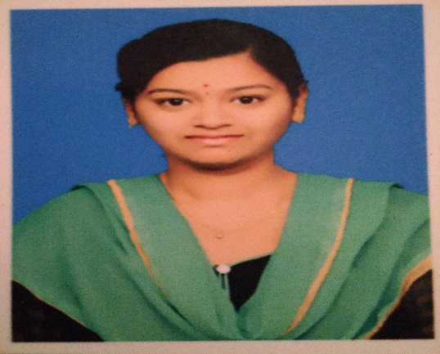
Total Experience: | 5.0 years
Relevant Experience: | 3.0 years
Notice Period: | LWD:30/04/23
MSP Input |  | Supplier Input
Candidate Skills | Mandatory/ Optional | Name of Projects in which  the skills were used  (Add rows if necessary) | No: of years worked  in each Project | Description of work done  using the skill
Primary Skill 1: | M |  |  | Performed NLP based preprocessing.
Primary Skill 2: | M |  |  | Machine Learning, Deep Learning, Natural Language Processing (NLP), Generative AI (GenAI).
Primary Skill 3: | M |  |  | Scikit-learn, NLTK tool kit, TensorFlow, Keras, Pytorch, Lang Chain, Matplotlib
Secondary Skill 1: | O
Secondary Skill 2: | O
Secondary Skill 3: | O

Yogitha Tappeta
Data Scientist /Machine learning Engineer
+916300221094 |yogithareddytappeta@gmail.com|linkedin.com/in/yogitha-tappeta-a84044194

Profile Summary

Data Scientist / ML Engineer with 5+ years of experience in Robert Bosch Engineering and Business Solutions (Payroll: Klaus IT Solutions Pvt Ltd (Apr 2018 – Jan 2020)) and Infobelt India Private Limited (Apr 2020 – Apr 2023).

Roles and Responsibilities

My roles and responsibilities as a Data Scientist revolve around
- Data collection, Data cleaning and pre-processing, Exploratory data analysis (EDA) using statistical techniques, visualization.
- Model Selection and Evaluation: Choose appropriate machine learning algorithms such as regression, classification, clustering, Natural language processing (NLP), Generative AI, Hugging face transformer model, Large Language Model (LLM), Transfer Learning and recommendation systems to build predictive models and solve business problems. Evaluate their performance using metrics.
- Feature Engineering.
- Model Deployment. • Interpretation and Communication.

Skills

Languages: Python, SQL
Technologies: Machine Learning, Deep Learning, Natural Language Processing (NLP), Generative AI (GenAI). Tools/Libraries/Frameworks: Scikit-learn, NLTK tool kit, TensorFlow, Keras, Pytorch, Lang Chain, Matplotlib,
Seaborn, PowerBi, Jupyter Notebook, VS code, Gilt repo, AWS and Azure (Basic Knowledge). Database: MySQL

Work Experience

Robert Bosch Lawn Mower
• Testing Robert bosch lawn mower in different lawn sizes, climatic conditions, my roles and responsibilities in this project is to writing test cases based on new feature enhancements, execute the same in the lawn, preparing the excel report with the results on lawn and submitting them to the higher officials.

Sentiment Analysis on Banking and Finance customer feedback
- The main objective of this project is to analyze the feedback of the customer and resolve these issues as soon as possible instead of manually analyzing the feedback.
- Extract data from database using SQL quires.
- Performed NLP based preprocessing.
- Developed LSTM deep learning algorithm to predict the sentiment polarity on customer feedback.
- Performed Hyper parameter tuning to increase the accuracy.
- Evaluating Model performance using classification metrices like Confusion matrix, precision, recall, F1-score, accuracy score, AUC-ROC curve etc.,

REGLIB Parsing Pipeline and Document Summarization using LLM’s
- The main objective of this project is to create a regulation library with all the financial documents and perform text summarization on top of that documents.
- HTML Web scraping performed using BeautifulSoup, and applied Regex to find out pattrens in data and developed a regulation library.
- Using Langchain framework parsing all these documents as chunks to Large Language model to perform summarization and finally give user understandable output.

Document Retrieval and Question Answering using LLM’s
- The Main objective of this project is to answering the financial questions asked by user in the form of prompts.
- Retrieval-Augmented Generation (RAG) concept of langchain and LLm’s to generate document chunks, get embedding for chunks and store embeddings with document chunk ID in vector database.
- As user ask the query it passes through the LLM creates embedding, chunk ID to retrive similar data from vector store and answer it.

Education

2013-2017: Bachelor of Engineering (EEE), Annamacharya Institute of Technology and Sciences (JNTUA), Kadapa, 78.23 percent.
2011-2013: Standard XII (MPC), Narayana Junior College, Kadapa, 92.5 percent.
2011: 10th/SSC, Sri Sai Krishna E.M High School, Kadapa, 87.16 percent.

